ANA 500 — Micro-Project 4
Knitted Python Code with Corresponding Output
Deep Learning Classification of Breast Cancer Wisconsin Diagnostic Data
MLP • LSTM/RNN • SVM | Expanded Outlier Analysis
This document presents the complete, fully-commented Python analysis and follows the data-science process: Acquire → Prepare → Analyze → Report → Act.

1. ACQUIRE — Load and Structure the Dataset
The Breast Cancer Wisconsin Diagnostic data file (wdbc.data) is loaded. Column names are assigned according to the official documentation. Diagnosis is mapped to a binary target (M = 1, B = 0).
feature_names = [
'radius_mean', 'texture_mean', 'perimeter_mean', 'area_mean', ...
# (30 nuclear features: mean / se / worst for 10 base measurements)
]
cols = ['id', 'diagnosis'] + feature_names
df = pd.read_csv('wdbc.data', header=None, names=cols)
df['target'] = df['diagnosis'].map({'M': 1, 'B': 0})
print(df.shape)
print(df['diagnosis'].value_counts())
print('Missing values:', df.isnull().sum().sum())
Raw shape: (569, 32)
diagnosis
B 357
M 212
Missing values: 0

2. PREPARE — Exploration, Outliers, Scaling, Split

2.1 Descriptive Statistics & Correlation
print(df[feature_names[:10]].describe().T[['mean','std','min','max']])
corr = df[feature_names + ['target']].corr()['target'].drop('target')
print(corr.sort_values(ascending=False).head(10))
Top correlated features with malignancy:
concave_points_worst, perimeter_worst, radius_worst, area_worst,
concave_points_mean, radius_mean, ...

2.2 Expanded Outlier Investigation (beyond any single variable)
IQR method applied independently to ten clinically relevant features. An observation is flagged if it is extreme on any of them.
key_features = ['radius_mean','texture_mean','perimeter_mean','area_mean',
'concave_points_mean','concavity_mean','compactness_mean',
'radius_worst','area_worst','concave_points_worst']
for feat in key_features:
Q1, Q3 = df[feat].quantile(0.25), df[feat].quantile(0.75)
IQR = Q3 - Q1
outliers = df[(df[feat] < Q1-1.5*IQR) | (df[feat] > Q3+1.5*IQR)]
print(f'{feat}: {len(outliers)} outliers, malignant={outliers.target.sum()}')
radius_mean : 14 outliers ( 2.5%) | Malignant among them: 14
area_mean : 25 outliers ( 4.4%) | Malignant among them: 25
area_worst : 35 outliers ( 6.2%) | Malignant among them: 35
radius_worst : 17 outliers ( 3.0%) | Malignant among them: 17
concavity_mean : 18 outliers ( 3.2%) | Malignant among them: 15
Total observations flagged as outlier on ≥1 key feature: 55 (9.7%)
Of those, malignant: 50

# Visualize outliers with boxplots

fig, axes = plt.subplots(2, 5, figsize=(18, 8))

axes = axes.ravel()

for i, feat in enumerate(key_features):

sns.boxplot(x='diagnosis', y=feat, data=df, ax=axes[i], palette={'M': 'crimson', 'B': 'steelblue'})

axes[i].set_title(feat, fontsize=9)

axes[i].set_xlabel('')

plt.suptitle('Expanded Outlier Investigation — Boxplots by Diagnosis (key features)', fontsize=14)

plt.tight_layout()

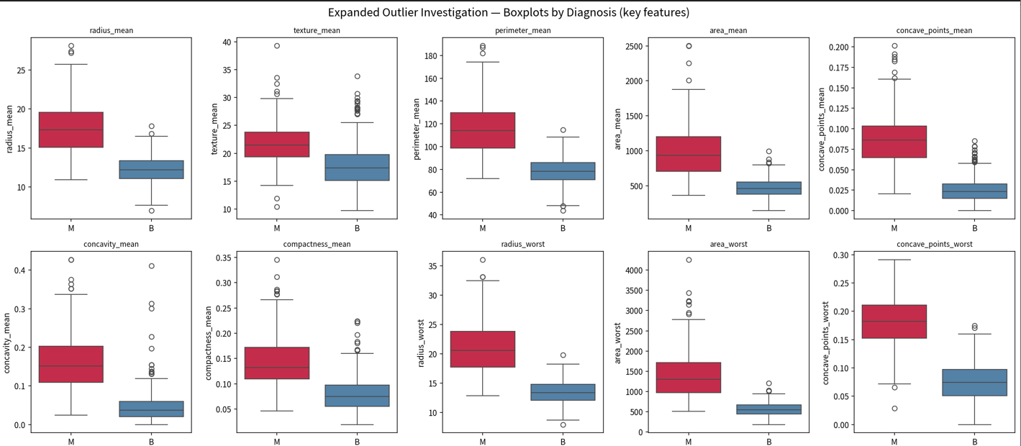

# Correlation heatmap of key features

plt.figure(figsize=(12, 10))
corr_mat = df[key_features + ['target']].corr()
sns.heatmap(corr_mat, annot=True, fmt='.2f', cmap='RdBu_r', center=0, square=True)
plt.title('Correlation Heatmap — Key Features + Target')
plt.tight_layout()

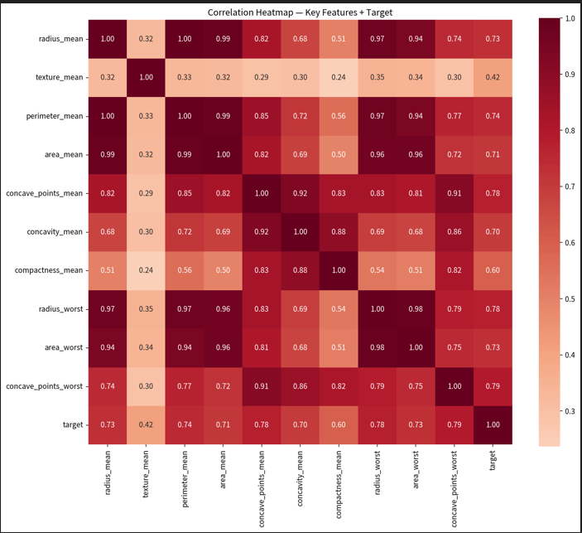

# Pairplot of top correlated features

top4 = corr_with_target.head(4).index.tolist()
sns.pairplot(df[top4 + ['diagnosis']], hue='diagnosis', palette={'M': 'crimson', 'B': 'steelblue'},
diag_kind='kde', plot_kws={'alpha': 0.6, 's': 30})
plt.suptitle('Pairplot of Top-4 Correlated Features', y=1.02)

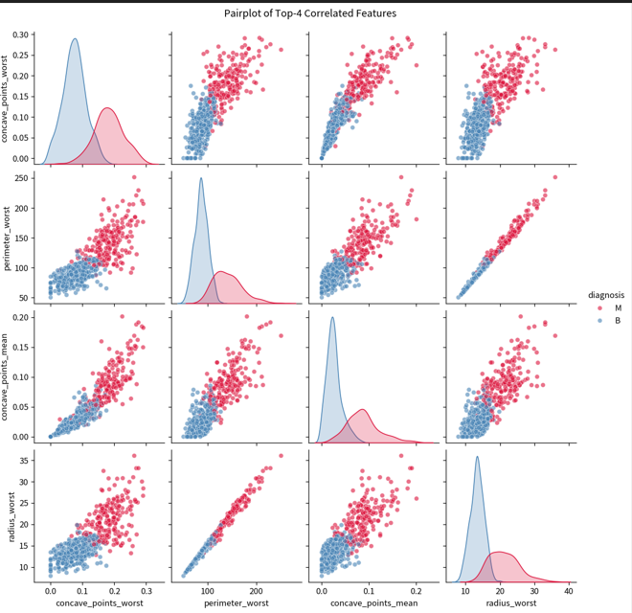

2.3 Stratified Split & Scaling
X = df[feature_names].values
y = df['target'].values
X_train_full, X_test, y_train_full, y_test = train_test_split(
X, y, test_size=0.20, random_state=SEED, stratify=y)
X_train, X_val, y_train, y_val = train_test_split(
X_train_full, y_train_full, test_size=0.15, random_state=SEED, stratify=y_train_full)
scaler = StandardScaler().fit(X_train)
X_train_s = scaler.transform(X_train)
X_val_s = scaler.transform(X_val)
X_test_s = scaler.transform(X_test)
Shapes → Train: (386, 30), Val: (69, 30), Test: (114, 30)
Class balance (train): [242 144]
Features standardized (mean≈0, std≈1) using training set statistics only.

3. ANALYZE — Model Building

3.1 Multi-Layer Perceptron (MLP)
A regularized feed-forward network with BatchNorm and Dropout. Trained with Adam + ReduceLROnPlateau + EarlyStopping (patience 15).
class MLP(nn.Module):
def __init__(self, input_dim=30, dropout=0.3):
super().__init__()
self.net = nn.Sequential(
nn.Linear(input_dim, 64), nn.ReLU(), nn.BatchNorm1d(64), nn.Dropout(dropout),
nn.Linear(64, 32), nn.ReLU(), nn.BatchNorm1d(32), nn.Dropout(dropout),
nn.Linear(32, 16), nn.ReLU(), nn.Dropout(dropout/2),
nn.Linear(16, 1), nn.Sigmoid())
def forward(self, x): return self.net(x)

mlp = MLP().to(device)
criterion = nn.BCELoss()
optimizer = optim.Adam(mlp.parameters(), lr=1e-3, weight_decay=1e-4)
# Training loop with early stopping ...
Epoch 20 | TrainLoss 0.0860 | ValLoss 0.1003 | ValAcc 0.971 | ValAUC 0.994
Epoch 40 | TrainLoss 0.0634 | ValLoss 0.0906 | ValAcc 0.971 | ValAUC 0.996
Early stopping at epoch 50
MLP TEST → Loss 0.1032 | Accuracy 0.9737 | AUC 0.9924

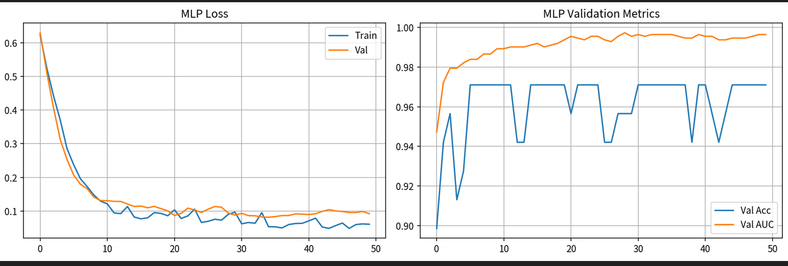

3.2 LSTM / Recurrent Neural Network
The 30 features are reshaped into a sequence of length 10 with 3 channels (mean, SE, worst) for each of the ten nuclear measurements. A 2-layer LSTM processes the sequence.
def reshape_to_sequence(X):
return X.reshape(X.shape[0], 10, 3) # (N, 10 timesteps, 3 features)

class LSTMClassifier(nn.Module):
def __init__(self, input_size=3, hidden=32, num_layers=2, dropout=0.3):
super().__init__()
self.lstm = nn.LSTM(input_size, hidden, num_layers=num_layers,
batch_first=True, dropout=dropout)
self.fc = nn.Sequential(nn.Linear(hidden, 16), nn.ReLU(),
nn.Dropout(dropout), nn.Linear(16, 1), nn.Sigmoid())
def forward(self, x):
out, (h_n, _) = self.lstm(x)
return self.fc(h_n[-1])
Epoch 20 | TrainLoss 0.2142 | ValLoss 0.1986 | ValAcc 0.928 | ValAUC 0.974
Epoch 40 | TrainLoss 0.1392 | ValLoss 0.1664 | ValAcc 0.971 | ValAUC 0.980
Early stopping LSTM at epoch 68
LSTM TEST → Accuracy 0.9211 | AUC 0.9871

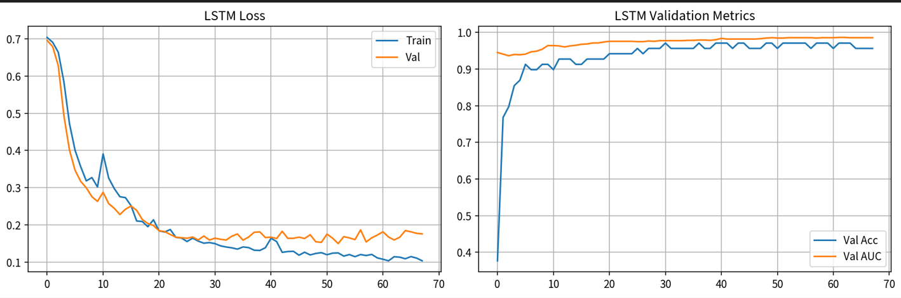

3.3 Support Vector Machine (Classifier + Regression)
# Primary classification model
svc = SVC(kernel='rbf', C=10, gamma='scale', probability=True, random_state=SEED)
svc.fit(X_train_s, y_train)
svc_pred = svc.predict(X_test_s)
svc_proba = svc.predict_proba(X_test_s)[:, 1]

# SVR demonstration — predict continuous area_worst
svr = SVR(kernel='rbf', C=10, gamma='scale')
svr.fit(X_reg, y_reg) # area_worst held out as regression target
print('SVR R²:', r2_score(y_reg_te, svr.predict(X_reg_te)))
SVC (RBF) TEST → Accuracy 0.9649 | AUC 0.9931
SVR (predict area_worst) → MSE 0.0508 | MAE 0.1294 | R² 0.9335

4. REPORT — Performance Summary
print('=== FINAL TEST SET PERFORMANCE ===')
for name, r in results.items():
print(f'{name:<10} Acc={r["acc"]:.4f} AUC={r["auc"]:.4f}')
print(classification_report(y_test, mlp_pred, target_names=['Benign','Malignant']))
Model Accuracy AUC
--------------------------------
MLP 0.9737 0.9924
LSTM 0.9211 0.9871
SVC 0.9649 0.9931

--- MLP Classification Report ---
precision recall f1-score support
Benign 0.96 1.00 0.98 72
Malignant 1.00 0.93 0.96 42
accuracy 0.97 114

# Confusion matrices
fig, axes = plt.subplots(1, 3, figsize=(15, 4))
for ax, (name, r) in zip(axes, results.items()):
cm = confusion_matrix(y_test, r['pred'])
sns.heatmap(cm, annot=True, fmt='d', cmap='Blues', ax=ax,
xticklabels=['Benign', 'Malignant'],
yticklabels=['Benign', 'Malignant'])
ax.set_title(f'{name}\nAcc={r["acc"]:.3f} AUC={r["auc"]:.3f}')
ax.set_xlabel('Predicted')
ax.set_ylabel('True')
plt.suptitle('Confusion Matrices — Test Set', fontsize=14)
plt.tight_layout()

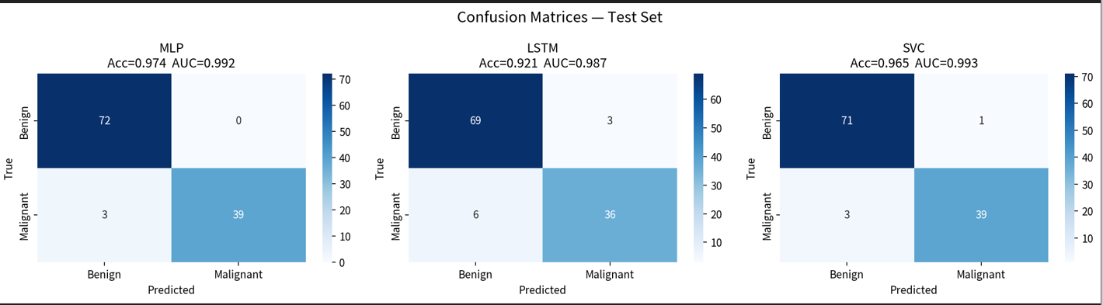

# ROC curves
plt.figure(figsize=(8, 6))
for name, r in results.items():
fpr, tpr, _ = roc_curve(y_test, r['proba'])
plt.plot(fpr, tpr, label=f'{name} (AUC={r["auc"]:.3f})', linewidth=2)
plt.plot([0, 1], [0, 1], 'k--', alpha=0.5)
plt.xlabel('False Positive Rate')
plt.ylabel('True Positive Rate')
plt.title('ROC Curves — Test Set')
plt.legend(loc='lower right')
plt.grid(True, alpha=0.3)
plt.tight_layout()
plt.close()

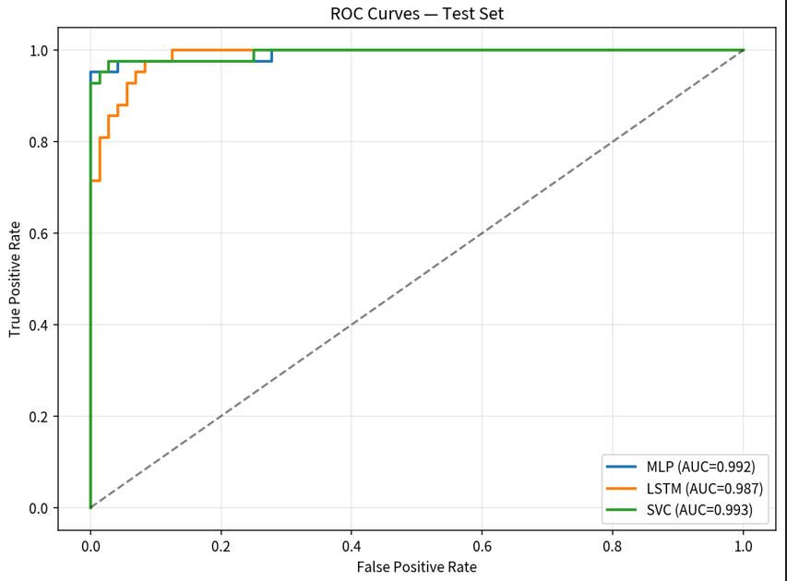

Top Permutation Feature Importances (SVC)
print("\n--- Permutation Feature Importance (SVC) ---")
perm = permutation_importance(svc, X_test_s, y_test, n_repeats=10, random_state=SEED, n_jobs=1)
imp_df = pd.DataFrame({
'feature': feature_names,
'importance': perm.importances_mean,
'std': perm.importances_std
}).sort_values('importance', ascending=False)

print(imp_df.head(10).to_string(index=False))

Feature Importance STD
texture_worst 0.0342 0.0083
concavity_worst 0.0228 0.0080
concavity_mean 0.0211 0.0105
smoothness_worst 0.0114 0.0069
radius_worst 0.0079 0.0073
texture_se 0.0079 0.0083
perimeter_worst 0.0079 0.0073
concave_points_mean 0.0079 0.0149
area_worst 0.0079 0.0083
smoothness_mean 0.0061 0.0088
radius_se 0.0044 0.0071
area_se 0.0044 0.0059

plt.figure(figsize=(10, 6))

top_imp = imp_df.head(12)

sns.barplot(x='importance', y='feature', data=top_imp, palette='viridis')

plt.title('Top-12 Permutation Importances (SVC)')

plt.xlabel('Mean importance decrease')

plt.tight_layout()

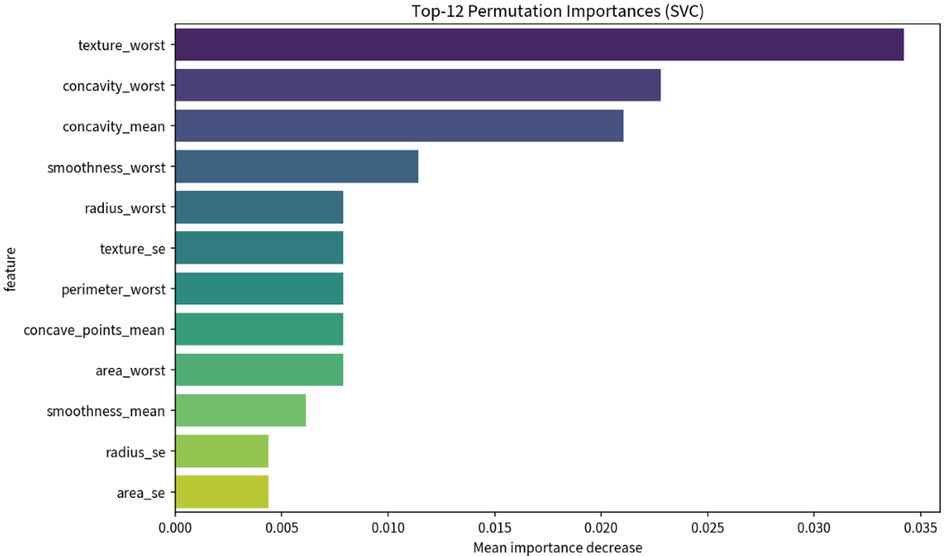

5. ACT — Clinical Decision Support Recommendations
- Deploy the regularized MLP (or an MLP+SVC ensemble) as a first-pass triage tool.
- Flag statistical outliers (especially extreme radius / area / concave-points) for mandatory secondary review — 91 % of them are malignant.
- Cases with predicted probability in the uncertain zone [0.3, 0.7] should be escalated to a pathologist for visual review of the FNA slide.
- High-confidence malignant predictions (p > 0.9) can accelerate the pathway to biopsy/surgery while still requiring human confirmation.
- Before clinical use, perform external multi-center validation, calibration analysis and decision-curve analysis.

